Policy & guidance approved 13 July 2026. Update due 14 July 2027.

CONTACT INFORMATION FOR DESIGNATED SAFEGUARDING OFFICERS
Maddy Crowther - maddy.crowther@wagingpeace.info or 020 8191 9235 or 07594 649 188
Board Safeguarding Lead Shaughnessy Hawkins - safeguardingtrustee@wagingpeace.info - if you want to escalate a concern, or if you can’t reach Maddy, or don’t feel comfortable contacting Maddy

Volunteer Guidance – Safeguarding yourself and others

When you volunteer with us it’s important to keep yourself and other people safe. This document will help you understand what to do in difficult situations.

Part 1: Staying safe
- Call for help if you believe you are at immediate risk of harm
  - If you are in immediate danger call 999.
  - If you are visiting someone in custody or detention, immediately contact [their relevant authority]
  - If you aren’t in immediate danger but are unsure of how to proceed or remove yourself from a situation, you can call us for assistance on 020 8191 9235 or another number which you have been provided, and leave a voicemail if you do not immediately reach us. It can be helfpul to email us and mark it urgent at info@wagingpeace.info.
- Never stay in a situation where you don’t feel safe or comfortable
  - You should always leave any situation, place or conversation where you feel uncomfortable, or think you might be at risk of harm. Nothing is more important than your well-being, and you should always trust your judgment.
- Tell us about any situation where you felt unsafe or uncomfortable
  - Once you’re safe from any immediate danger, get in contact with us. We want to support you in any way necessary and we want to avoid the same happening to other volunteers, so it’s important for us to know about your experience as soon as possible.
- Think twice before sharing information about yourself
  - We recommend you don’t share your mobile phone number with the people you are meeting with. If you think they’re in danger, follow the guidance in part 3. You should also avoid sharing other personal details about yourself.
- Make time for self-care
  - You also need to look after yourself! Set and maintain personal boundaries, and make time to relax and unwind. If you are unclear on what boundaries might be helpful, discuss this with us.
  - We run sessions for our volunteers to debrief and share their experiences, which can also be very beneficial in feeling calm about the difficult situations you may face. You are more than welcome to join these sessions – contact us for more details.
- If you’re volunteering through another organisation, make sure you follow their guidance
  - Check if they have any guidance and make yourself familiar with their recommendations on how to respond to incidents, and who to contact for support.
  - If you experience an issue while volunteering with another organisation and you share it with us, we will have to tell them about the concerns you raise. In most cases we can keep your experience anonymous, but when there’s a serious concern we may need to share your personal details with the other organisation. We will always try to get your consent before doing so, but in some cases we’ll legally have to disclose them anyway.
Part 2: Ensuring we don’t harm the individuals we work with

We have to make sure we don’t harm anyone we work with.

As a volunteer this means you must:
- Keep any information regarding the individuals you support strictly confidential, even from other volunteers. This includes information that could identify them, like name and contacts, but also details that could be used to work out who they are, such as age or where they are from.
- Not disclose to anyone where the individuals you support are staying, or details about their cases.
- Respect people’s dignity and autonomy: don’t act against their wishes and stated needs, and acknowledge their experiences and perspectives.
You also need to let us know if you have concerns about Waging Peace’s practices (particularly if you believe they are not safe or could cause harm), safeguarding, risk management, behaviour, and social distancing. This includes where the issue relates to Waging Peace itself, or any individual working with us. You can read our full Safeguarding Policy statement here, and our policies and procedures here with appendices. Contact our Designated Safeguarding Officer Maddy Crowther at maddy.crowther@wagingpeace.info or 020 8191 9235 about your concerns, or our Board Safeguarding Lead Shaughnessy Hawkins (safeguardingtrustee@wagingpeace.info) if you want to escalate a concern, or if you can’t reach Maddy, or don’t feel comfortable contacting Maddy.

Part 3: What to do if you suspect that someone you are supporting is at risk of harm or abuse

In case of emergency: Act immediately to ensure the individual’s safety and well-being. This may include calling the appropriate emergency service. Once their safety and well-being has been ensured, immediately inform the Waging Peace Designated Safeguarding Officer, Maddy.

In all other cases: Follow the guidance below – make sure you take detailed notes, and contact the Waging Peace Designated Safeguarding Officer, Maddy within 24 hours wherever possible. If you want to escalate a concern, can’t reach Maddy or want to talk to someone other than Maddy, you can reach our Board Safeguarding Lead Shaughnessy at safeguardingtrustee@wagingpeace.info.

What is a safeguarding concern?

Safeguarding concerns may arise in any situation where you are concerned that an individual is at risk of harm and/or abuse of any kind, including where the individual is at risk of harming themselves or others. Concerns may arise because of a direct disclosure from the individual involved, or other observations and feedback. It’s important that we take any safeguarding concern seriously.

Harm or abuse can take any number of forms, and any individual may be at risk. Examples of types of abuse can be found in our Safeguarding Policy, along with more information about how we respond to safeguarding concerns as an organisation.

If someone discloses that an individual is at risk of harm and/or abuse to you (a “safeguarding concern”), you should do the following:
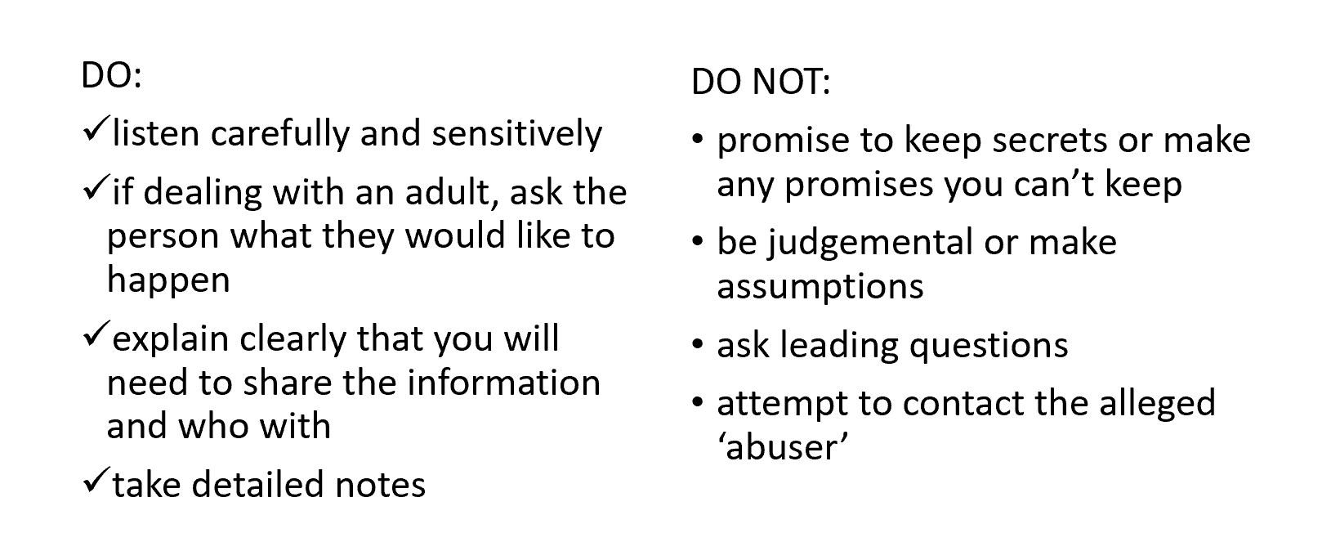
Remember that it’s not your job to investigate the disclosure - you just need to ascertain the basic facts so that you can help Waging Peace respond to the concerns appropriately. You should never discuss any disclosures with anyone except for our Designated Safeguarding Officer, Maddy, our Board Safeguarding Lead, Shaughnessy, or any individual filling in for them when they are unavailable – this means you should not even discuss it with other Waging Peace volunteers and staff.

You should report your concerns to Maddy within 24 hours wherever possible.

What happens next will depend on whether the individual is (a) a child, (b) a “vulnerable adult”, or (c) an adult that is not considered vulnerable for safeguarding purposes. This is because there are specific legal requirements Waging Peace needs to follow in the event that a child or vulnerable adult is at risk.

Next steps: children
If the individual is a child (under 18 years of age), you must share all information regarding the concern or disclosure with Maddy. You can let the child know that you will be doing this, but you can’t protect their confidentiality from the disclosure to Waging Peace in any situation.

Waging Peace (through Maddy, Shaughnessy or an individual filling in for them) will receive your disclosure and will make the relevant disclosures to the right authorities/individuals to ensure the situation is investigated and the concern addressed.

Bear in mind that our actions should ensure the promotion of children’s health and welfare, including their physical, emotional, social, and intellectual development. This means that we treat children as individuals entitled to dignity and respect, and promote the safety of children at all times.

Next steps: vulnerable adults
With adults, you should always try to get their consent to share their information with Waging Peace and the authorities. You should also ask them what they would like to happen next. However, if they are a vulnerable adult you will need to disclose the situation to Waging Peace regardless.

First, you must assess whether the individual is a vulnerable adult, considering the criteria below.

According to the Care Act 2014, safeguarding applies to any adult who:
- Has care and support needs, and
- Is experiencing, or is at risk of, abuse or neglect, and
- Is unable to protect themselves from either the risk of, or the experience of abuse or neglect, because of those needs.

If you are uncertain whether the criteria are met, you should discuss the assessment with us (on a no-names basis, if they have not given consent). We will be able to assist you with the assessment and make a determination of whether or when it would be appropriate to waive confidentiality.

Your responses to disclosures of potential harm or abuse by vulnerable adults, and Waging Peace’s response to such disclosures, should always take into account the following principles:
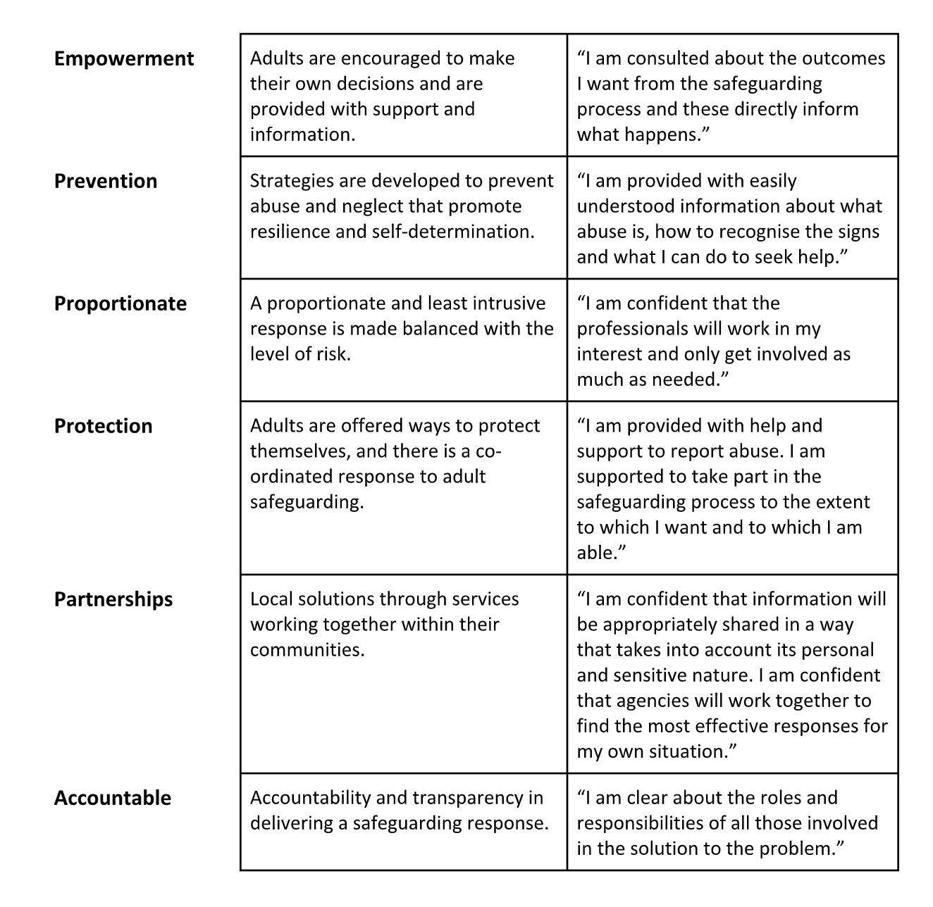
If the Care Act criteria are met, you need to disclose the full details of the concern with Waging Peace, to Maddy or Shaughnessy (or someone filling in for them). They will work with you and the individual involved to ensure that the concerns are managed appropriately, taking into account the principles above and Waging Peace’s legal obligations. They will keep you updated on progress to the extent permitted by law.

Next steps: Other adults
Even if an individual is not vulnerable, we will still want to support them. In these cases, we will almost always follow their specific wishes regarding how to handle a situation – this includes confidentiality and next steps.

If the individual hasn’t consented to you sharing their information with us, you will still need to disclose some high-level details of the situation with us so that we can deal with the relevant risks, make sure we are complying with the law (there are, for example, certain rules regarding domestic abuse in Home Office accommodation), and maintain appropriate records. You can do this on a no-names basis, and you should ensure that you respect their stated wishes wherever possible while you make this disclosure. Even though it may not be a safeguarding issue, Maddy will still be your point of contact for any such issues.

If the individual has consented to us disclosing their situation to the authorities, or if disclosure is required by law, Maddy will take the lead in doing this in order to protect everyone involved. Otherwise, Maddy will help you identify community resources that may be able to support the individual with their specific situation, which you can pass along to the individual, and help you identify whether we should support them.

